ABSTRACT
This case study investigates the impact of AI learning tools on student performance using a dataset of 50,000 learning sessions. We analyze relationships between tool usage patterns, perceived usefulness, ease of use, trust, and student outcomes, including pre- and post-test scores, task completion, and satisfaction levels.
Exploratory Data Analysis (EDA) is employed to visualize trends and correlations across variables such as session frequency, duration, hints requested, and adaptive difficulty levels. Additionally, sentiment and emotion analysis on student feedback is incorporated to understand learners’ perceptions and attitudes toward AI-assisted learning. The study aims to identify key factors influencing both academic performance and user satisfaction, providing insights for educators and developers to optimize AI tools for effective learning.

INTRODUCTION
Artificial Intelligence (AI) has increasingly become integrated into modern learning environments, offering support through adaptive feedback, personalized recommendations, and interactive assistance. As students engage with AI tools for academic tasks, understanding how these technologies influence learning outcomes becomes essential. With the rapid adoption of AI-assisted platforms, there is growing interest in how usage patterns, perceived usability, trust, and user feedback relate to academic performance and overall satisfaction.
This study explores the effect of AI tool interaction on student learning using a dataset of 50,000 recorded sessions. It examines how factors such as session frequency, duration, task completion, hint usage, and sentiment expressed in feedback contribute to measurable improvement in student performance. Through both statistical analysis and machine learning techniques, the study aims to provide evidence-based insights into how AI tools shape learning experiences and outcomes.

OBJECTIVES:
(1) To analyze student interaction patterns using metrics such as session count, average session duration, and weekly AI tool usage. (2) To evaluate the relationship between AI tool engagement and academic performance through improvement scores, tasks completed, and adaptive difficulty levels. (3) To assess user satisfaction and perception of AI tools by examining perceived usefulness, ease of use, trust, and satisfaction scores. (4) To incorporate sentiment and emotion analysis of text feedback using polarity, subjectivity, sentiment labels, and primary emotion categories. (5) To provide data-driven insights to guide the optimization of AI-assisted learning systems for improved educational outcomes.

METHODOLOGY
The analysis follows a structured approach similar to traditional OLS-based research designs, adapted for multiple linear regression using Python libraries such as pandas, scikit-learn, seaborn, and matplotlib.
(1) Data Collection and Preparation: The dataset contains variables related to AI tool usage, student attitudes, ethical concerns, and academic performance, including pre-test and post-test scores. Data preparation involved selecting relevant numerical predictors, and preparing the dataset for regression modeling using
pandas. Exploratory data analysis (EDA) was conducted through seaborn and matplotlib to visualize distributions, correlations, and improvement patterns.
(2) Model Specification and Representation: A multiple linear regression model was selected to examine how AI-related factors, usage frequency, perceived usefulness, trust, and ethical concerns influence post-test scores. The model specifies post-test score as the dependent variable, with predictors representing behavioral, perceptual, and contextual measures of AI tool adoption.
(3) Coefficient Estimation Using Linear Regression: The model was trained using scikit-learn’s LinearRegression. A Lasso regression model was additionally applied to identify the most influential features through regularization and feature selection.
(4) Prediction of Values: The dataset was divided into training and testing subsets. Predictions on the test set were generated to assess how well the model generalizes to unseen data. Metrics such as R² were computed to evaluate predictive accuracy.
(5) Interpretation and Visualization of Results: Scatter plots and comparison graphs were produced using seaborn, ggplot2 and matplotlib to visualize predicted versus actual post-test scores, as well as improvements from pre-test to post-test. The regression coefficients were analyzed to identify which AI-related factors significantly contribute to student performance. Lasso-selected features further clarified the variables with the strongest explanatory power.
Findings
figure 1: grade levels
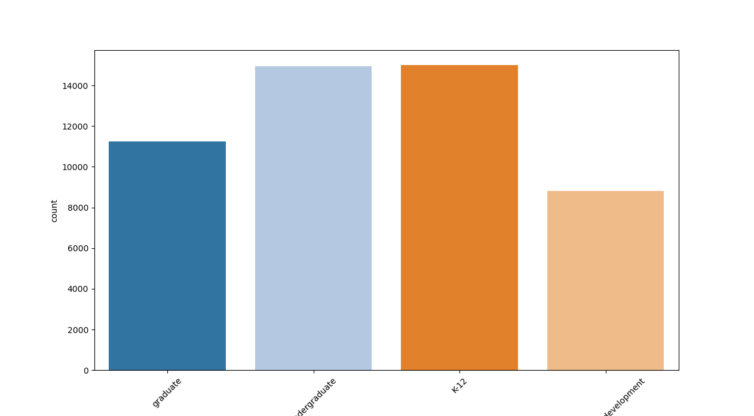
This bar graph shows that there’s more Ai users on K-12(Orange) and undergraduate(light blue) level. This suggests that AI tools are more commonly adopted among students in K-12 and undergraduate levels, possibly due to easier access, greater integration in learning activities, or higher curiosity and willingness to try new technology at these stages.
Figure 2: T test result

T-test result shows that Ai Usage among students mostly have a positive impact on their final scores. With the mean difference of 7.722 and p value of almost 0.
Source
Case Study Source Codes.
https://github.com/AlieeLinux/case-study2

